#Intepretation for Customer Profile
#Gender
#Product Female Male
#TM195 40 40
#TM498 29 31
#TM798 7 33

# Product TM195 is equaly purched by males and females,
# TM498 is almost equal males and female while
# TM798 is more used by Males
# TM198 is sold more and TM798 is sold less.
# Males spend more in Fitness products

MaritalStatus
Product Partnered Single
TM195 26.67 17.78
TM498 20.00 13.33
TM798 12.78 9.44

Looking at the product range between Married and Single, Married people have bought the products more than single.

, , MaritalStatus = Partnered

Gender
Product Female Male
TM195 15.00 11.67
TM498 8.33 11.67
TM798 2.22 10.56

, , MaritalStatus = Single

Gender
Product Female Male
TM195 7.22 10.56
TM498 7.78 5.56
TM798 1.67 7.78

Product TM195 and TM498 are being liked by married Male equally.
Similarity, Single Females like TM195 and TM498 very closely.
More products are purchased by Married people then single.

boxplot(Income~Product, horizontal = TRUE, col=rainbow(9))

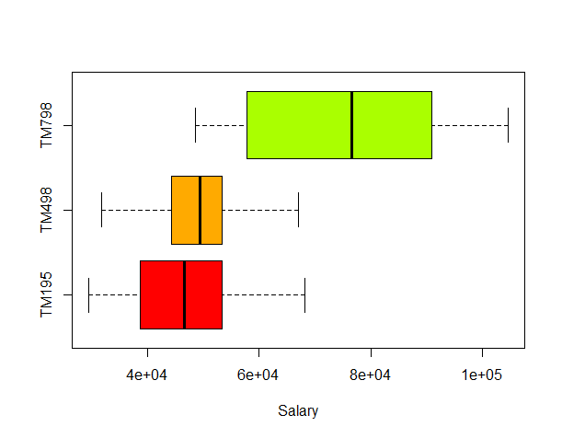
TM798 is purchased by People with higher salary level.

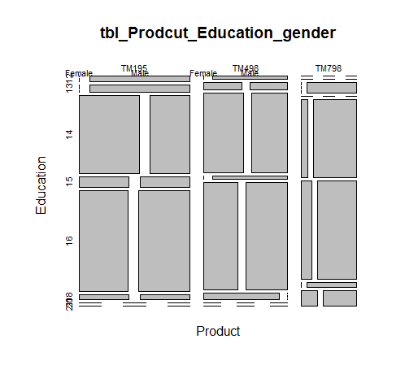
Education level of 16 and 14 tend to buy 195 and 498

Scripts
## Statistical Models and Decision Making
## Instructor : P.K. Vishwanathan
## Date : 20-Jan-2017
## Case 2 - CardioGood Fitness
##The market research team at AdRight is assigned the task to
#identify the profile of the typical customer for each treadmill
#product offered by CardioGood Fitness. The market research
#team decides to investigate whether there are differences across
#the product lines with respect to customer characteristics. The
#team decides to collect data on individuals who purchased a
#treadmill at a CardioGood Fitness retail store during the prior
#three months. The data are stored in the CardioGoodFitness.xls
#file. The team identifies the following customer variables to study:
# product purchased, TM195, TM498, or TM798; gender; age, in
#years; education, in years; relationship status, single or partnered;
#annual household income ($); average number of times the
#customer plans to use the treadmill each week; average number
#of miles the customer expects to walk/run each week; and self-
#rated fitness on an 1-to- 5 ordinal scale, where 1 is poor shape
#and 5 is excellent shape.
# 1. Compute descriptive statistics to create a customer profile for
#each CardioGood Fitness treadmill product line.
#2. Write a report to be presented to the management of CardioGood
#Fitness, detailing your findings.

CardioGoodFitness.src = read.csv("C:/Home/Work/GreatLakes/R/ClassWorkOuts/CardioGoodFitness.csv")
attach(CardioGoodFitness.src)

#Building Cross table
table1 = round(prop.table(table(Product, Gender))*100,2) #Will also calculate the %
#Intepretation for Customer Profile
#Gender
#Product Female Male
#TM195 40 40
#TM498 29 31
#TM798 7 33

# Product TM195 is equaly purched by males and females,
# TM498 is almost equal males and female while
# TM798 is more used by Males
# TM198 is sold more and TM798 is sold less.
# Males spend more in Fitness products
table2 = round(prop.table(table(Product, MaritalStatus))*100,2) #Will also calculate the %

table3 = round(prop.table(table(Product, Gender,MaritalStatus))*100,2) #Will also calculate the %
# When peopl get married, they tend to prchase items. In that TM195 has highest rate of purcahse rate shift from single to married, esp. Female.

table3
table2

table(Product, MaritalStatus)

ageGroups = seq(from=min(Age), to = max(Age), by=8)
table(cut(Age,ageGroups,right = FALSE))
table

by(CardioGoodFitness.src, INDICES = Product, FUN = summary)
# Number of Males and Females are Equal.
# income of the group of people 798 is more than other two products
summary(CardioGoodFitness.src)

boxplot(Age~Product, horizontal = TRUE, col=rainbow(8))
# for TM195 is skewed towards 25
boxplot(Education~Product, horizontal = TRUE, col=rainbow(9))
boxplot(Income~Product, horizontal = TRUE, col=rainbow(9), xlab="Salary")
plot(Age,Product)

# Q1 = 1 * ((n+1)/4)
# Q2 = 2 * ((n+1)/4)
# Q3 = 3 * ((n+1)/4)
# If Q is decimal

boxplot(Usage~Product)
boxplot(Usage~Product)

FitnessSource = read.csv("C:/Home/Work/GreatLakes/R/ClassWorkOuts/CardioGoodFitness.csv")
attach(FitnessSource)
tbl_Prodcut_Education_gender = table(Product,Education,Gender)
plot(tbl_Prodcut_Education_gender)

